**Part 1: Test Design**

**User Stories:**

* **[TRELLA-1]**

1. Test case 1 steps: {Check that all existing shipments displayed and try to bid on one of them}

* Login to the app
* Navigate to all available shipments.
* Check that all the shipments are displayed
* Select one shipment to bid on.

1. Test case 2 steps: {Check the availability to bid on many shipments at the same time}

* Login to the app
* Navigate to all available shipments.
* Try to bid on more the one shipment.

1. Test case 3 steps: {check the performance}

* Login to the app with 100 users at the same time
* Navigate to all available shipments screen.
* check the performance of the app
* Try to bid on one shipment with 100 users at the same time.
* Check the performance of the app.
* Try to bid on different shipment with 100 users at the same time.
* Check the performance of the app.
* **[TRELLA-2]**

1. Test case 1 steps: {Check Filter with location functionality}

* Login to the app
* Navigate to all available shipments screen
* Select the filter button to show the nearby shipments only
* Check if the displayed shipments are near to user’s current location
* Check if the nearby shipments are updated if a new shipment added or removed from the existed list.
* **[TRELLA-3]**

1. Test case 1 steps: {Check the functionality of the web}

* Login to the Web
* Navigate to Track my shipments screen.
* Check that the shipper’s shipments exists and displayed.
* Check that the shipper can view the bids.
* Check the real-time insights

1. Test case 2 steps: {Check that shipper account is being updated}

* Login to the Web
* Navigate to Track my shipments screen.
* Use the app and try to bid on the shipper shipments.
* Check that the bids are updated on the shipper account.

**Part 2: Bug Report**

**Defect 1: Limited Displayed Data**

Steps:

1. Open the App
2. Only 10 shipments are displayed
3. Click “Show nearby” button
4. Then click the button again

Expected Result: Another 10 shipments are displayed and the previous 10 are lost.

Attachment:

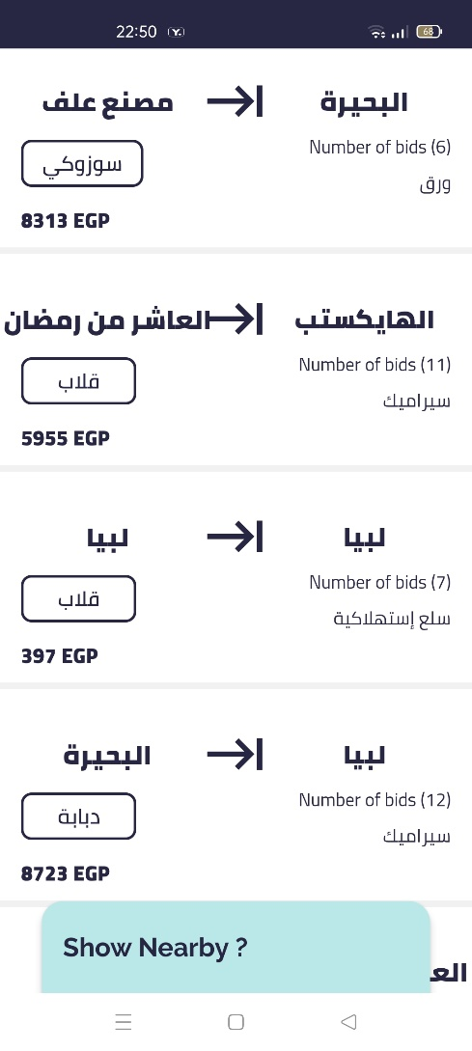

**Defect 2: Font Issue**

Steps:

1. Open the App
2. All available shipments displayed
3. Check the shipment with long place name like “العاشر من رمضان”

Expected Result: The name clashes with the arrow of the direction

Affected Device: Oppo Reno 4 (Android Phone)

Attachment:



**Defect 3: Limited Nearby shipments**

Steps:

1. Open the App
2. All available shipments displayed
3. Click “Show nearby” button
4. Only 3 shipments are displayed
5. Refresh the page by navigating back to all available shipments screen and then navigate to nearby shipments screen

Expected Result: Another 3 shipments are displayed and the previous 3 are lost.

Affected Device: Oppo Reno 4 (Android Phone)

Attachment:

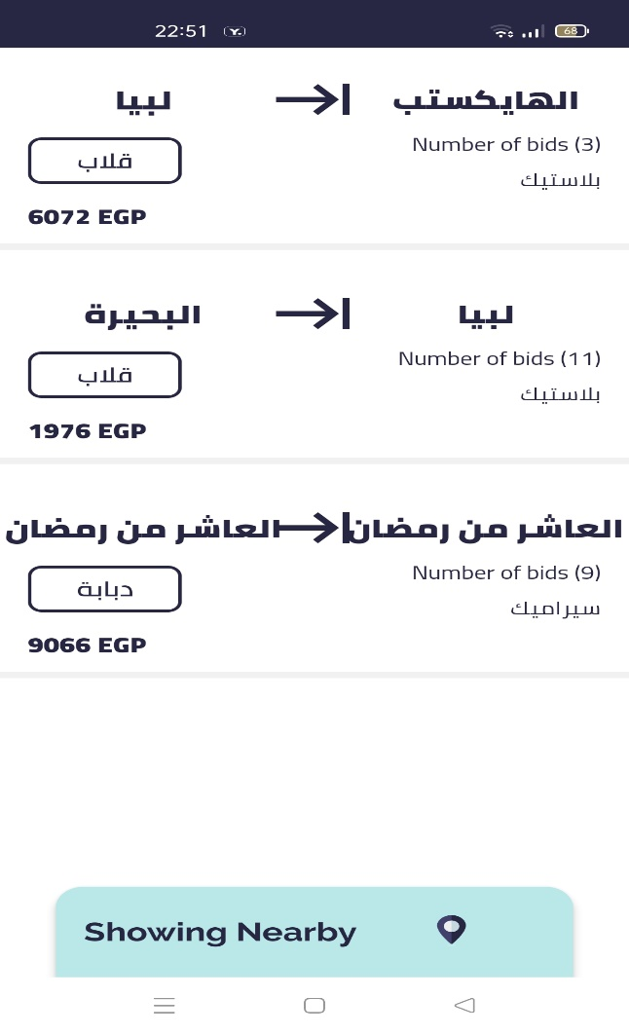

**Defect 4: Unstable screen**

Steps:

1. Open the App
2. All available shipments displayed
3. Click “Show nearby” button
4. 3 shipments are displayed
5. Wait until the page gets updated

Expected Result: Screen malfunction occurs.

Affected Device: Oppo Reno 4 (Android Phone)

Attachment:

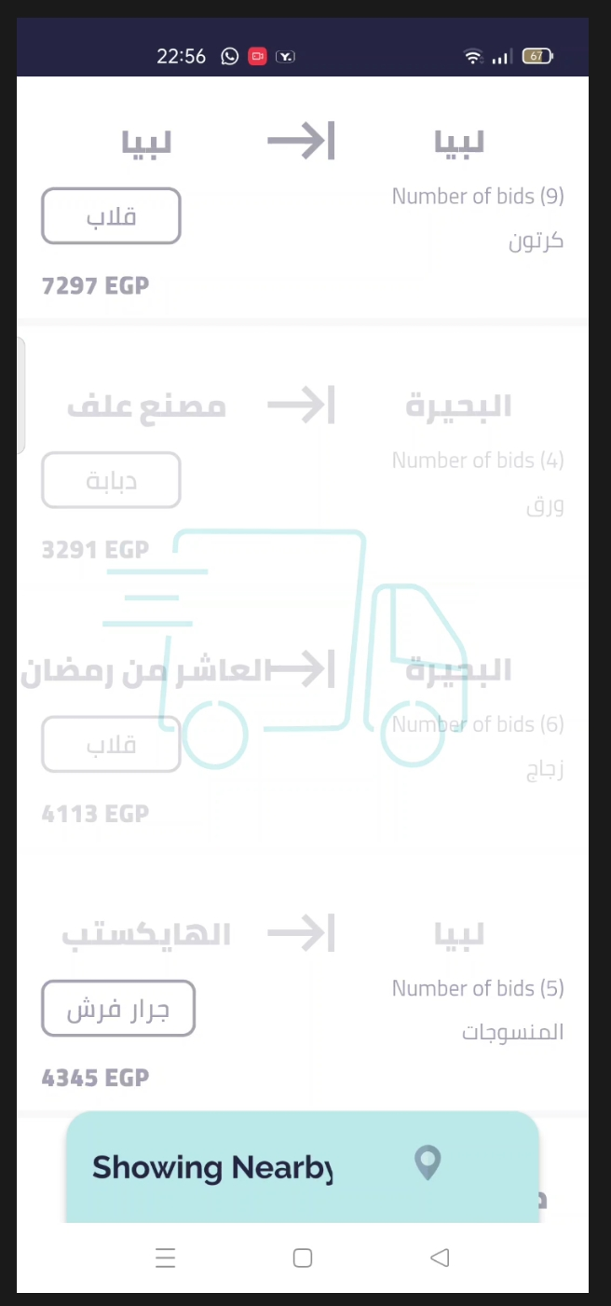

Part 3: Automation

Please Note:

1. Change the path of your chrome with your path in line 51
2. Change the path of the image to be saved with your path in line 115
3. Please write your Facebook credentials username and password in lines 62,63